Software Requirements Specification
for
Martinique
Version 1.0 approved
Prepared by
Subhajeet Bairagi
Aswini Vinay Soreng
Subhamastoo Sidharth
Digbijay Mahapatra
IIIT Bhubaneswar
4th October 2018
Table of Contents
Table of Contents ii
Revision History ii
1. Introduction 1
1.1 Purpose 1
1.2 Document Conventions 1
1.3 Intended Audience and Reading Suggestions 1
1.4 Product Scope 1
1.5 References 1
2. Overall Description 2
2.1 Product Perspective 2
2.2 Product Functions 2
2.3 User Classes and Characteristics 2
2.4 Operating Environment 2
2.5 Design and Implementation Constraints 2
2.6 User Documentation 2
2.7 Assumptions and Dependencies 3
3. External Interface Requirements 3
3.1 User Interfaces 3
3.2 Hardware Interfaces 3
3.3 Software Interfaces 3
3.4 Communications Interfaces 3
4. System Features 4
4.1 System Feature 1 4
4.2 System Feature 2 (and so on) 4
5. Other Nonfunctional Requirements 4
5.1 Performance Requirements 4
5.2 Safety Requirements 5
5.3 Security Requirements 5
5.4 Software Quality Attributes 5
5.5 Business Rules 5
6. Other Requirements 5
Appendix A: Glossary 5
Appendix B: Analysis Models 5
Appendix C: To Be Determined List 6

Revision History
Name | Date | Reason For Changes | Version

Introduction

Purpose
This SRS describes the requirements and specifications of Martinique, a system for Medicine Shop Automation. It explains the functional features of the system, along with interface details, design constraints and related considerations such as performance characteristics. The SRS is intended for the chemists and druggists of major medicine merchandise.

Document Conventions
1.2.1 JIT

Just in time or JIT is a methodology aimed primarily at reducing flow times within production as well as response times from suppliers and to customers. Under this philosophy, actual orders dictate what should be manufactured, so that the exact quantity is produced at the exact time as is required. The inventory management system of this MSA system is based on the JIT philosophy.

1.2.2 Threshold Value

Threshold value of any medicine is the quantity of that medicine that should be present in stock at all times to sustain selling for about one week.
The MSA is designed to calculate the weekly average sale of a particular medicine based on the sale records of the previous 4 weeks thus allowing the shop owner to always adhere to the JIT philosophy.

1.2.3 Medicine Description

A short summary that contains information about the ailments that the medicine can be used against, the dosage of the medicine and the possible side effects of the medicine. This can also include information about the active and passive ingredients of the drug.

1.2.4 Code Number

A unique number that is generated for every new medicine procured by the shop owner which he had not dealt in earlier. It is automatically generated by the MSA the first time the medicine shop procures a new medicine. It is also used for reference on all further dealings related to that particular medicine.

1.2.5 Generic Name

Each medicine has an approved name called the ​generic name. A group of medicines that have similar actions often have similar sounding generic names.

1.2.6 Trade Name

Every medicine also has a ​trade name. This is chosen by the vendor that it has been purchased from. Several vendors may sell the same generic medicine, each with their own trade name. The name is often chosen to be memorable for advertising, or to be easier to say or spell than the generic name.

1.2.7 GUI (Graphical User Interface)

GUI is a type of interface that allows users to interact with electronic devices through graphical icons and visual indicators such as secondary notation, as opposed to text based interfaces, typed command labels or text navigation. As the name suggests, this sort of interface makes the system a lot more user friendly and makes it easy to use.

The Martinique MSA is completely GUI based which helps in increasing the owner system
interactions.

1.2.8 OSS (Opensource software)

Opensource software (OSS) is computer software with its source code made available with a license in which the Copyright holder provides the rights to study, change, and distribute the software to anyone and for any purpose. Opensource software may be developed in a collaborative public manner. Opensource software is the most prominent example of opensource development.

1.2.9 SQL

Structured Query Language (SQL) is a special purpose programming language designed for managing data held in a relational database management system (RDBMS), or for stream processing in a relational data stream management system (RDSMS).

The Martinique MSA uses SQL for storing the information on medicines and vendors securely​.

Intended Audience and Reading Suggestions
This document of Software Requirements Specification for the MSA is intended mainly for :
  - Developers

  - People involved with System maintenance

  - Customer ( for the automation software)

Product Scope
The Martinique MSA is intended to reduce the various laborious tasks of the medicine shop owner. It reduces inventory management overhead by implementing the just in time (JIT) philosophy. As much a managerial philosophy as an inventory system, JIT encompasses all activities required to make a final product from design engineering onwards to the last manufacturing operation. JIT systems are fundamental to time based competition and rely on waste reduction, process simplification, setup time and batch size reduction and parallel (instead of sequential) processing.

In addition, the Automation is also capable of handling specialized queries that might be required by the shop owner for efficient management of his stocks. For example, it can generate on being queried, a vendor wise list of expired medicines which can then be easily replaced. It can also provide accurate figures for revenue and profit for any valid specified period.

Overall Description

Product Perspective
A retail medicine shop deals with a large number of medicines procured from various manufacturers. For systematic and efficient functioning of the shop, the shop owner needs to maintain his inventory in a well ordered manner. The Medicine Shop Automation Software not only helps in inventory management following JIT philosophy, it also provides a centralized overview of the functioning of the medicine shop. All transactions of the medicine shop can be recorded and the database updated accordingly. The database not only stores information about the medicines, but also required details of the vendors the shop owner deals with. The system can also generate the list of expired items to be replaced, new items to be ordered and keep track of the revenue and profit in overall or periodwise transactions.

In this way, the MSA provides the much needed automation to reduce labour and increase efficiency in the customer dealings of the medicine shop.

Product Functions
The main purpose of the Martinique MSA is to maximize user utility. It can handle a wide range of userspecific queries.

The MSA allows the shop owner to efficiently handle huge amounts of information regarding a large number of medicines by allowing him/her to perform the following functions:

- Create records of any new medicine procured by the shop

- Update existing records of medicines that are already in stock

- Query the details of any medicine by using either its Trade Name or its Generic Name

- Generate the list of all medicines whose stock needs to be replenished

- Generate the list of all medicines which have expired.

In addition, the Martinique MSA also automatically performs useful functions such as

- Print out cheques in favour of the vendor when medicines are purchased.
- Print out the cash receipt every time the shop sells a medicine.

- Calculate the threshold value of every medicine and ensure that every medicine is in stock.

The Martinique Medicine Shop Automation should embody the following features and functions:

- Should be able to enforce medicine purchases according to sales performance of each medicine.

- The calculation of sales performance should be dynamic, and not static, which is a necessary implication of the JIT philosophy, so that the quantity of medicines purchased is only the quantity that is necessary.

- Should be scalable, which means that its performance should not degrade with the addition of new medicine records and/or vendor records to the database.

- Should be configurable, and allow handling of other specific queries that may be necessary for required by the shop owner.

- Should provide administrative security in terms of a password protected login system for the shop owner.

User Classes and Characteristics
The targeted user for the MSA is the owner of the medicine retail shop. The MSA can be operated even by a layman possessing basic knowledge about handling software. Therefore, no specialized skills are needed from the user to use the interface.

Operating Environment
Operating environment for the medicine automation system is as listed below:
- distributed database
- client/server system
- Operating system: Windows / Linux
- database: SQL+ database
- platform: HTML/CSS/JavaScript

Design and Implementation Constraints
The probable constraint on the project is the availability of a proper computing platform setup in the medicine retail shop. The software requires a computer with no specialized features other than the minimum additional hardware like a printer to implement the functionality of printing cheques and cash memos. Its overall functionalities are platform independent. However, since the software is coded in Node.js with MySQL for handling large data, the computer needs to be preinstalled with dependencies like express,v8,body-parser and tools like npm and nodemon. For testing purposes, any computer with Node.js and npm with a working Internet connection can be used.

Assumptions and Dependencies
A number of factors that may affect the requirements specified in the SRS include:

ASSUMPTIONS:

- The database records for the medicines which the shop owner deals in are created at the time of procurement of new medicines which the shop owner had never sold before. The records are updated every time a fresh stock arrives or some transaction occurs.

- The quantity for the initial stocks for the medicine shop must be decided upon by the shop owner since the calculation of the threshold value for JIT will need the sales figures for at least one week.

- In case the shop stops selling a particular medicine, perhaps because it’s sale has been banned or it went out of production, the shop owner must himself/herself delete the record for that particular medicine from the database.

- In case the shop no longer buys medicines from a certain vendor, the shop owner must also delete the record corresponding to that particular vendor from the database.

DEPENDENCIES:

- The Martinique MSA depends on the status of the MySQL server as the automation relies on the MySQL service to store the required information regarding medicines and the vendors.

External Interface Requirements

User Interfaces

3.1.1 Login Page

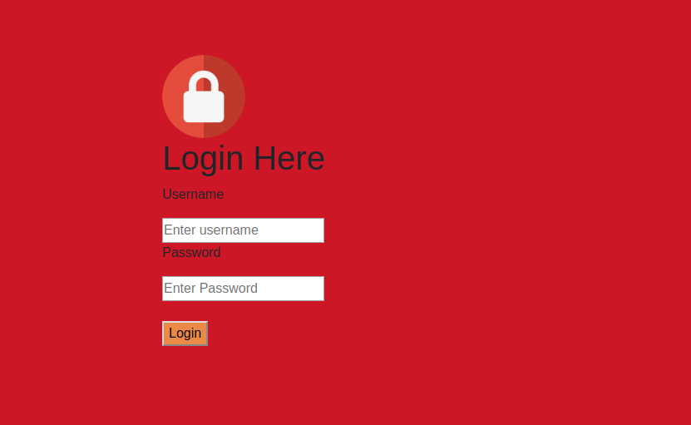

3.1.2 Welcome Page
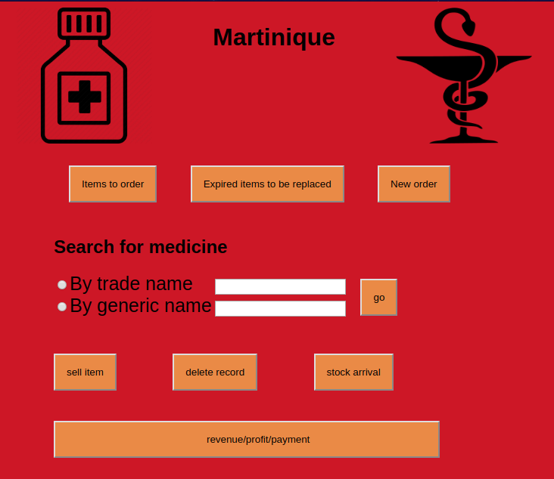

Hardware Interfaces
Windows/Linux
A browser which supports CGI, HTML and Javascript

Software Interfaces
Following are the software used for the Medicine Automation Shop
Software used | Description
Operating System | We have chosen both Windows and Linux operating system for its best support and user friendliness.
Database | To save medicine details, customer details and Retailer records we have chosen SQL + Database.
HTML, CSS, JavaScript | To implement the project we have chosen HTML, CSS and JavaScript for it’s interactive support.

Communications Interfaces
This project supports all type of web browsers. We are using JavaScript to update and maintain the medicine database.

System Features
4.1Description and Priority
A retail medicine shop deals with a large number of medicines procured from various manufacturers. For systematic and efficient functioning of the shop, the shop owner needs to maintain his inventory in a well ordered manner. The Medicine Shop Automation Software not only helps in inventory management following JIT philosophy, it also provides a centralized overview of the functioning of the medicine shop. All transactions of the medicine shop can be recorded and the database updated accordingly. The database not only stores information about the medicines, but also required details of the vendors the shop owner deals with. The system can also generate the list of expired items to be replaced, new items to be ordered and keep track of the revenue and profit in overall or period wise transactions. In this way, the MSA provides the much needed automation to reduce labour and increase efficiency in the customer dealings of the medicine shop.

4.2 Stimulus/Response Sequences
- Search for the availability of the medicine
- Display the details of the user, medicine, retailer shop
4.3 Functional Requirements
The main purpose of the Curiosity MSA is to maximize user utility. It can handle a wide
range of user specific queries.
The MSA allows the shop owner to efficiently handle huge amounts of information
regarding a large number of medicines by allowing him/her to perform the following
functions:
- Create records of any new medicine procured by the shop
- Update existing records of medicines that are already in stock
- Query the details of any medicine by using either its Trade Name or its Generic Name
- Generate the list of all medicines whose stock needs to be replenished
- Generate the list of all medicines which have expired.
- Calculate the threshold value of every medicine and ensure that every medicine is in stock.
The Curiosity Medicine Shop Automation should embody the following features and functions:
- Should be able to enforce medicine purchases according to sales performance of each medicine.
- The calculation of sales performance should be dynamic, and not static, which is a necessary implication of the JIT philosophy, so that the quantity of medicines purchased is only the quantity that is necessary.
- Should be scalable, which means that its performance should not degrade with the addition of new medicine records and/or vendor records to the database.
- Should be configurable, and allow handling of other specific queries that may be necessary for required by the shop owner.
- Should provide administrative security in terms of a password protected login system for the shop owner.

Appendix A: Glossary
JIT
Just in time or JIT is a methodology aimed primarily at reducing flow times within production as well as response times from suppliers and to customers. Under this philosophy, actual orders dictate what should be manufactured, so that the exact quantity is produced at the exact time as is required. The inventory management system of this MSA system is based on the JIT philosophy.

Threshold Value
Threshold value of any medicine is the quantity of that medicine that should be present in
stock at all times to sustain selling for about one week.
The MSA is designed to calculate the weekly average sale of a particular medicine based on the sale records of the previous 4 weeks thus allowing the shop owner to always adhere to the JIT philosophy.

Medicine Description
A short summary that contains information about the ailments that the medicine can be used against, the dosage of the medicine and the possible side effects of the medicine. This can also include information about the active and passive ingredients of the drug.

Code Number
A unique number that is generated for every new medicine procured by the shop owner which he had not dealt in earlier. It is automatically generated by the MSA the first time the medicine shop procures a new medicine. It is also used for reference on all further dealings related to that particular medicine.

Generic Name
Each medicine has an approved name called the generic name. A group of medicines that have similar actions often have similar sounding generic names.

Trade Name
Every medicine also has a trade name. This is chosen by the vendor that it has been purchased from. Several vendors may sell the same generic medicine, each with their own trade name. The name is often chosen to be memorable for advertising, or to be easier to say or spell than the generic name.

GUI (Graphical User Interface)
GUI is a type of interface that allows users to interact with electronic devices through graphical icons and visual indicators such as secondary notation, as opposed to text based interfaces, typed command labels or text navigation. As the name suggests, this sort of interface makes the system a lot more user friendly and makes it easy to use.
The Curiosity MSA is completely GUI based which helps in increasing the owner system interactions.

OSS (Opensource software)
Opensource software (OSS) is computer software with its source code made available with a license in which the Copyright holder provides the rights to study, change, and distribute the software to anyone and for any purpose. Opensource software may be developed in a collaborative public manner. Opensource software is the most prominent example of opensource development.

SQL
Structured Query Language (SQL) is a special purpose programming language designed for managing data held in a relational database management system (RDBMS), or for stream processing in a relational data stream management system (RDSMS).
The Curiosity MSA uses SQL for storing the information on medicines and vendors securely .

